**CTL checker**

**A project by**

1. **Ganesh Gaiy (ANE80)**
2. **Pranay Jasti (xxp12)**
3. **Parthasarathi Kota()**
4. **Sarath Baswa()**

**Group 1 section 1**

**Aim:**

To develop a Java standalone application that implements the CTL model checking analysis and for the verification of the properties in the CTL temporal logic.

**Project description:**

The developed application should be able to take the name of the file as the input that contains the definition of the kripke structure for which the property should be

checked and a CTL formula that defines the property, the input file will be loaded in the GUI.

The application will perform syntax verification and display an error message if the kripke structure is not analysed. If the kripke structure is successfully analysed, the output can be seen on the GUI. The CTL formula is entered into the GUI text field which provides the correct syntax. The system will show an error message if a kripke structure is not parsed successfully.

**Figure 1**: GUI of the Model System

**Figure 2**: Loading a Kripke Structure Test File

**Figure 3**: The overview of the application

1. **Acceptance testcases**

We have implemented for model 2, model 4 and model 5 for the CTL Formulas.

**Model 2**

i)CTL formula: **AG(EF(p or r))**

Starting state: s0

Property AG(EF(p or r)) hold in state s0

**Model 4**

i)CTL formula: **AG(t1 -> AF c1)**

Starting state: s7

Property AG(t1 -> AF c1) hold in state s7

**Model 5**

i)CTL formula: **EXp;**

Starting state: s4

Property EXp does not hold in state s4

**Microwave oven test:**

i)CTL formula: **AG(s->AFh);**

Starting state: s1

Property AG(s->AFh) does not hold in state s1

ii)CTL formula: **AG(->AFh);**

Starting state: s1

Invalid CTL Expression

1. **Description of execution of acceptance testcases illustrated with screenshots of all the windows and pop-up windows of the system and console output along an acceptance testcase**

**Model 2**

CTL formula: AG(EF(p or r))

Starting state: s0

**Figure 4:** Property AG(EF(p or r)) hold in state s0

**Kripke Structure for model 2**

**Model 4**

i)CTL formula: AG(t1 -> AF c1)

Starting state: s7

**Figure** Property AG(t1 -> AF c1) hold in state s7

**Kripke Structure for model 4**

**Model 5**

i)CTL formula: EXp;

Starting state: s4

**Figure** Property EXp does not hold in state s4

**Kripke Structur for Model 5**

**Microwave oven test:**

i)CTL formula: **AG(s->AFh);**

Starting state: s1

Property AG(s->AFh) does not hold in state s1

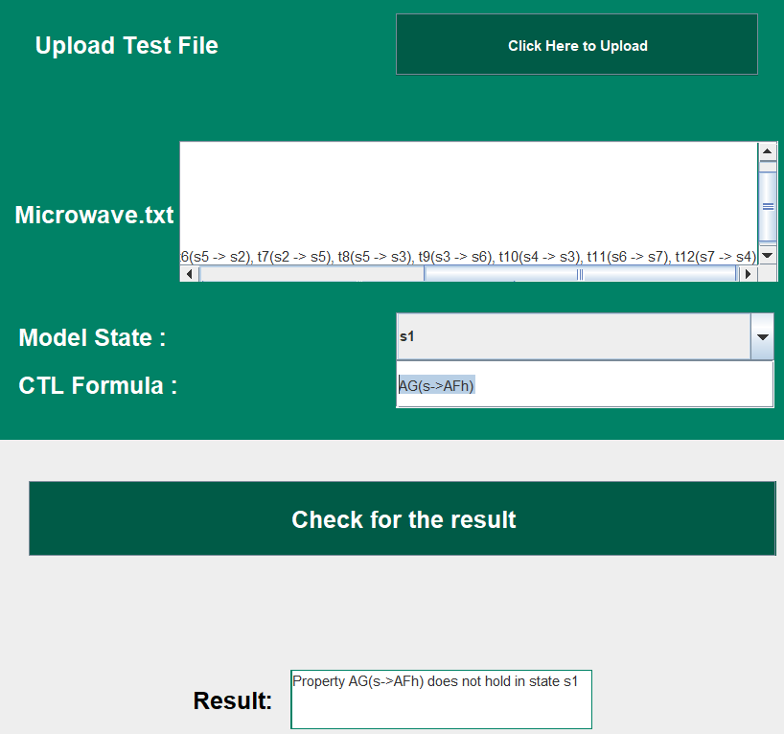

**ii)** CTL formula: **AG(->AFh);**

Starting state: s1

Invalid CTL Expression

